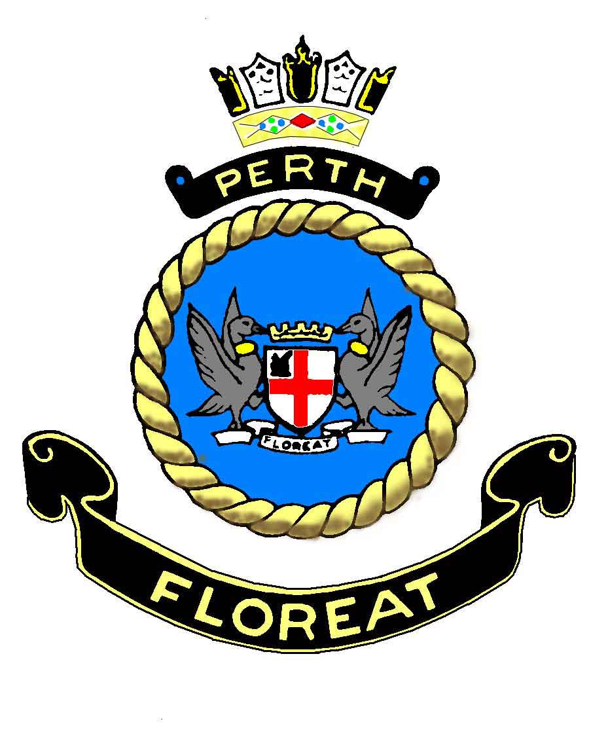 RAY PARKIN’S ODYSSEY by Pattie Wright 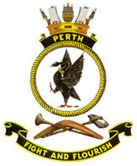

“It wasn’t as bad as you think and worse than you can ever imagine”
Ray Parkin.

Nothing excites us more than a great true story expertly told.
HMAS Perth National Association [Victoria Area]

The biography of Chief Petty Officer Ray Parkin will be available in bookstores nationally from 18 September 2012, published by Pan Macmillan. It is just shy 700 pages and will retail for $49.99.

The book has been written by Pattie Wright, author of ‘The Men of the Line’ (Miegunyah Press, 2008). After taking four years to write Ray’s biography, it is to be hoped that the men who contributed to its pages – the precious few surviving from HMAS Perth and their compatriots in USS Houston, ex-POW’s of the Thai Burma railway and those from Ohama, in Japan – will approve. It has been written for all of you in mind.

For those not au fait with the history:

In 1939, Ray Parkin was serving in the Australian light cruiser, HMAS Perth. At first glance he looked every inch the archetypal petty officer that he was – tough, practical and a model of naval discipline. Yet Ray was no ordinary sailor, despite a lack of formal education he had the soul of an artist, and a philosopher’s enquiring mind.

As HMAS Perth was embroiled in war – first in the Caribbean, then the horror of the Mediterranean campaign and finally into the fight for South East Asia - Ray was to become both a witness and a chronicler to the conflict through his meticulous diaries and his minutely observed watercolours and sketches. When Perth was sunk off the coast of Java, Ray was one of the survivors. After a valiant attempt to sail back to Australia in a ship’s lifeboat, he surrendered and spent the rest of the war as a prisoner of the Japanese. First, in building the Thai Burma railway and then working as a slave labourer in a Japanese coal mine. The horrors and privations of those years saw some of his most memorable artwork – documenting both the beauty of the natural world and the savageries and humiliations of the POW experience.

These were also the years that saw the founding of life-long friendships with fellow prisoners Weary Dunlop and Laurens van der Post. These seemingly lost years gave Ray the material for three exemplary books he would publish after the war, each one documenting his experiences: ‘Out of the Smoke’, ‘Into the Smother’ and ‘The Sword and the Blossom’.

Ray died in 2005, acclaimed not only for his art and his wartime trilogy, but also for his prize-winning masterpiece, H. M. Bark Endeavour, an extraordinary evocation of Captain Cook’s ship and the voyage up the east coast of Australia in 1771.

This extensively researched biography, illustrated by 100 paintings, photographs and sketches is the first full and comprehensive account of Ray’s life and wartime experiences. Using first hand accounts from filmed interviews with Ray himself as well as access to his letters, diaries and unpublished memories, Pattie Wright has written a book that is powerful, moving and compelling.

